**Urban Heat Island (UHI) Mitigation Dashboard**

**Identify areas most vulnerable and susceptible to high energy use during heatwaves**

The platform aims to assist urban planners, local governments, and stakeholders in identifying areas where the urban heat island effect is most severe, particularly for vulnerable populations (and areas with poor energy efficiency), and to propose actionable mitigation strategies. These strategies can help reduce energy consumption for cooling, improve air quality, and lower greenhouse gas (GHG) emissions.

Identify areas that are excessive heat zones:

**Identify sites/heat zones in New York City at block level**:

Scale problem:

1. Temperature data
2. Air quality data

Prioritisation:

1. Income and demographics data
2. Building efficiency rating data

**Recommend a suite of solutions to adapt/mitigate**:

1. Green roofs: Identify potential sites for green roofs
2. Tree cover: Identify sites for tree cover
   1. Sidewalks that don’t have trees
   2. Sidewalks where there are restaurants
3. Cool pavements: Identify pavements that are due repair or don’t use color
4. Cool roads: Identify roads due for repair or those that use poor material

**Develop projections for each recommended solution:**

1. Estimate temperature reduction
2. Translate that into emissions reduction

**Put all of this together in a dashboard:**

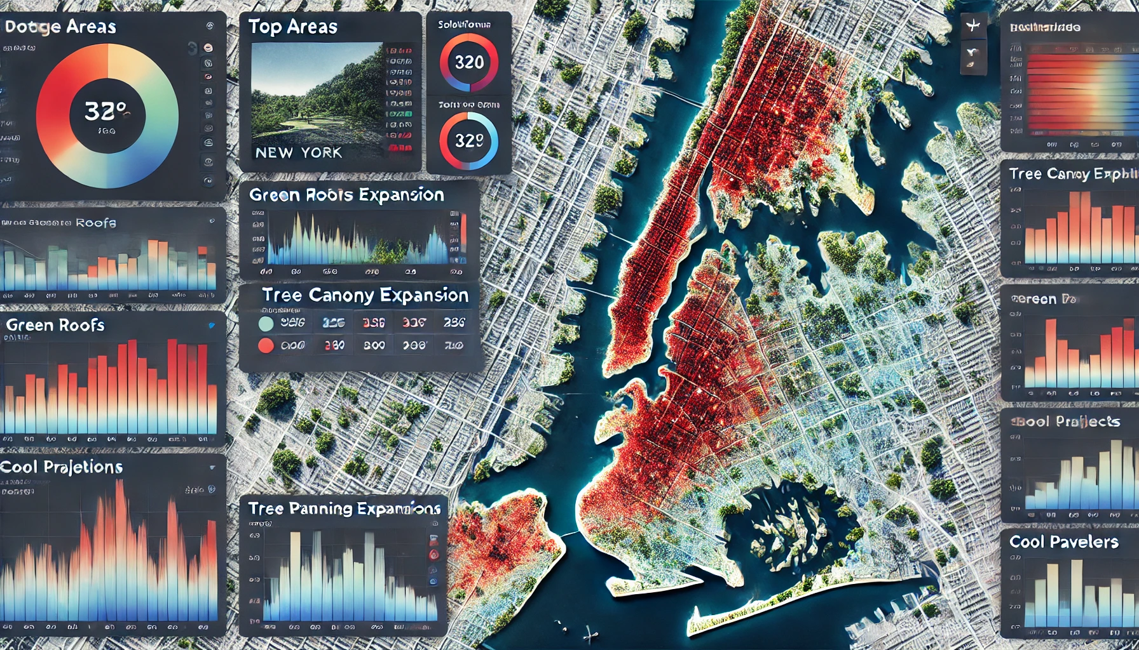

Street shed approvals during the pandemic did not predict maximum temperatures in 2019. This is good evidence that there isn’t a confounding variable or reverse causation here and a negative impact on temperatures in the post Covid period would be do to real factors.

